Response to reviewers

Review 1 (Reviewer A)

- in a calibration architecture like the one proposed by the Authors, the location of the step change should be known in advance since the user defines the signal model of the test waveforms.

R: The architecture of the proposed calibrator is similar to that adopted by few National Metrology Institutes, in that the reference values are estimated by processing sampled signals, instead of using the nominal values set in the generation module. Besides, we note a growing demand for calibrating commercial calibration systems that do not allow the user to set all parameters of the signal generation model [add reference]. Therefore, reliably estimating the step location from the sampled signals becomes necessary. We revised both the abstract and the Introduction to clarify this point.

Moreover, the accuracy of the proposed estimation techniques and the reliability of the detectors is not compliant with the requirements of a calibration system whose accuracy should exceed the expected one of the DUTs by at least one order of magnitude;

R: PMUs are not required by the IEEE Std to provide any estimate of the step location inside the frame. Therefore, the Review’s statement cannot be proven nor disproven. The purpose of the investigation was to assess the accuracy of the signal generation modules of PMU calibrators, particularly for the estimation of step location inside a particular frame. We now emphasize in the text that the step location estimation is a part of a larger calibration system, with other signal processing modules that are in charge of estimating the underlying phasor parameters.

- the literature review has to be improved with specific reference to other existing PMU calibration architectures, the detection of power quality events (like step changes), and the analysis of PMU performance during transient conditions;

R: We have improved the Introduction section accordingly.  
  
- the problem of defining phasor and frequency during transient events is currently subject of many papers in the literature. During a step change, the signal energy is not conveyed by the only fundamental component, but it is spread all over the spectrum. In such a scenario, the definition of phasor and frequency associated to the fundamental component looses its significance. Also for this reason, the IEEE Std introduces the concept of response time and almost neglects the PMUs' accuracy in the presence of a step change.

R: We are very aware of why the IEEE Std uses the concept of response time during a step change. The Reviewer certainly knows that research in this field goes beyond the conservative bounds of the IEEE Std. The research challenge lies precisely in estimating the underlying phasor parameters [ref] despite of the step change. For that, advanced signal modeling and estimation techniques have already been reported in the literature. For instance, [Frigo] and [our TIM paper] tackle the problem with parametric models and nonlinear estimation methods. Those techniques require a priori knowledge of the step location. Therefore, a detector that provides an accurate estimate of the step location is justified. This is the main focus of our paper. Since the detector is based on the instantaneous frequency (FI), it was natural and immediate to evaluate how well a very simple FI-based estimator of the underlying phasor frequency would perform. Not surprisingly, the performance is not sufficient for calibration purposes, as we acknowledged in the paper. Nevertheless, it is our understanding that the performance can be improved by means of signal denoising techniques. We modified the text to make the above points clearer to the reader.

As a consequence, the analysis of FE during step change might lead to results not easy to interpret, and recent literature has introduced alternative performance indicators like Normalized Root Mean Squared Error and Goodness of Fit;

R: Yes, these are alternative performance indicators to the standard TVE, and they can be used to evaluate the goodness of fit of a phasor estimate. However, this is not in the scope of our paper, which is devoted solely to estimating accurately the step location inside a frame and providing a rough estimate of the underlying frequency. These are useful input information for more advanced phasor estimation techniques, which can be then evaluated by the aforementioned indicators.

- the implementation of Hilbert Transform strongly affects the accuracy of the instantaneous estimates of amplitude, frequency and phase. The HT computation can be obtained via two main approaches: Fourier Transform or filtering. Both these approaches do not provide the best performance in the presence of a step change. The FT relies on a stationary signal model and can only approximate (i.e. distort) a step change event. The filtering approach instead introduces a delay and smoothing effect that depends on the filter order and magnitude/phase response. In this sense, the estimate provided by the analytic signal might be not totally reliable for this application;

R: We demonstrated by solid numerical simulations that our hybrid detector provides accurate step location estimates, regardless of the whatever intrinsic well-known limitations of the Hilbert transform to obtain the phasor analytic signal. The proof is in the pudding. For the underlying phasor frequency, the estimator is notably very simple, and we duly report its limitations. Nevertheless, it is our understanding that there is room for improvement and that the performance can be increased by means of signal denoising techniques.  
  
- the performance of the proposed detectors should be tested also in off-nominal or other dynamic conditions, in order to verify the robustness of the proposed thresholds.

R: The proposed detectors are not intended to be used in other dynamic conditions, but only the step-like ones, based on the models prescribed by the IEEE Std. Off-nominal frequencies are not prescribed in the step tests. We ran tests for constant off-nominal phasor frequencies and there is no significant change in performance. For the detection signal given by eq. (8), the influence of the fundamental frequency is strongly reduced by the subtraction of the median of fi.

- the adopted sampling rate is rather low (4.8 kHz). This means that the spectral bandwidth of the observed phenomena is limited to 2.4 kHz (assuming that an anti-aliasing filter is employed). Furthermore, this low sampling rate limits also the resolution of the detectors as the step change is associated to a given sampling time;

R: We assure the Reviewer that standard PDS techniques have been properly used. Increasing the sampling rate will only make the step detection task easier, since the step will be more accurately represented in the sampled phasor waveform. Consequently, the proposed detector will provide an even more accurate time location estimate for the step. We emphasize that the time accuracy we report is within a couple of sampling periods (inverse of the sampling frequency of 4.8kHz. i.e., less than 0.5 ms), which is already pretty high in comparison with the fastest report interval of a typical PMU, which is in the order of half the duration of a phasor cycle (approx. 8 ms). Nevertheless, if time accuracy way higher than 0.5ms is needed, it suffices to increase accordingly the sampling rate, at the cost of a higher computational load.

- the adopted thresholds rely on the assumption of normal distribution. How are the mean and standard deviation computed, i.e. over which time-window? Or is the algorithm run off-line? The Authors should provide a qqplot or a histogram in order to verify this assumption;  
  
R: We use a frame of 6 phasor cycles, comprising 480 samples. All calculations are carried out with these samples. The hybrid detector can be run in real-time, provided enough processing power is available. Moreover, the algorithm is data-driven, i.e., the thresholds vary from frame to frame. The detection signals are constructed from the instantaneous functions h_i_[n] and f_i[n]. In the absence of spikes, the stochastic additive noise that contaminates these functions is normally distributed, since they are attained via linear operations over x[n], also corrupted by normally distributed noise. We verified that, as shown in the histograms below, for SNR=30dB.

More specifically, the unbiased STD estimates of h_i_[n] (magnitude) and f_i[n] (frequency) are, respectively, calculated by median(d_m[n]) and median(d_f[n]), over the 480 samples in the frame. These are precisely the well-known median absolute deviation (MAD) robust estimates [10] of the stochastic noise STDs, as explained in the end of Section III.B.

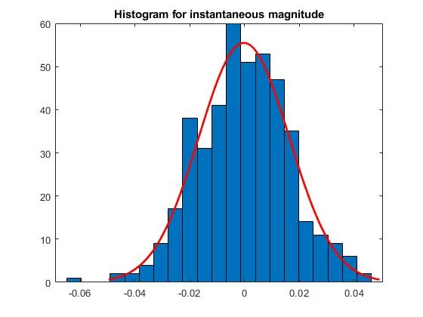

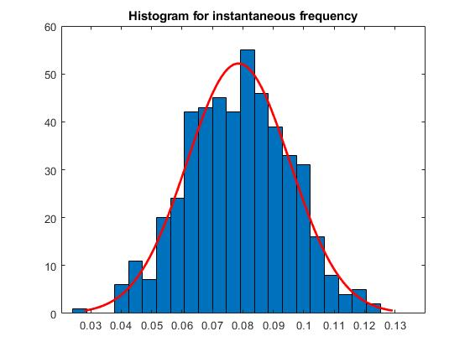

- the tested SNR levels prove the robustness of the adopted technique but are not realistic for PMU applications where a lower level of noise is expected. In this context, what is the delay and distortion introduced by the measurement chain: Amplifier + Divider?  
  
R: Indeed, SNRs lower than 60 dB are not realistic for calibration purposes. The performance reported for 60 dB is a worst case for calibration. The detection performance is expected to be better as SNR increases. The analysis for SNRs lower than 60 dB gives us limits for other potential application contexts. Regarding the delay and distortion introduced by the Amplifier + Divider, we expect to have some information when we run tests with these components. As for now, it is beyond the scope of this paper to have an accurate characterization of them. That is why they were wiped out of the circuit for the validation of the method, as we stated in the beginning of Section IV.B.

"As a main remark, the reference section should be largely extended, to reflect the significant work currently under development in several labs on the subject of PMU calibration systems."

R: We have expanded the Introduction section accordingly.

Review 2 (Reviewer B)  
  
The authors may want to explicitly define the contribution of this paper with respect to reference [6] and possibly compare (or rather reference instead of duplicating) the results to [6] for the common cases.

R: We have modified the text to clarify the scope of the work. We report the development of initial stages of a larger system, regarding step location inside a frame and frequency estimates. In [6], we used only the detector based on instantaneous frequency described by eq. (8), i.e., II-B2, for particular choices of \phi_0. Now, we formally define a hybrid detector, which incorporates also the detection of instantaneous magnitude. The performance of the hybrid detector is assessed in a wide range for \phi_0.

Review 3 (Reviewer C)

The topic is interesting and coherent to AMPS’s scope. The paper is well written.

As a main remark, the reference section should be largely extended, to reflect the significant work currently under development in several labs on the subject of PMU calibration systems.

R: We have expanded the Introduction section accordingly.

More tests should be provided in the numerical simulations to assess the performance of the detectors. In particular, it seems to have little sense testing each detector only against the specific steps it looks for. On the contrary, the performance of the three detectors should be compared in all situations. Concerning the simultaneous presence of amplitude and phase steps, considering them as simultaneous represents again a too favorable situation for the hybrid detector. Test with non-simultaneous step would represent a “fairer” test

R: We respectfully disagree with the distinguished reviewer, since evaluating the performance of a specialized detector outside its application scope is unfair. As regards the task of step detection and location, our main proposition is the hybrid detector, which does not require previous information on the step type. We only reported the performance of the primary (magnitude and frequency) detectors to shed light on the performance figures of the hybrid detector. We recognize that this was not clearly conveyed in the text. On the other hand, we agree with the Reviewer that the hybrid detector must be evaluated for the three cases. We now report the results in Section III.B.